|  |
| --- |
| **International School**  CAPSTONE PROJECT 1  **CMU-SE-450**  Proposal Document  v 2.2  Green Big5 Information System  Submitted by  Chinh, Thai Huu  Chung, Hoang Bao  Hau, Bui Phuc  Loc, Nguyen Tien  **Approved by**  **Capstone Project 1 - Mentor:**  Name Signature Date  Binh, Thanh Nguyen __________________31 - Nov- 2021 |

**PROJECT INFORMATION**

|  |  |  |  |  |
| --- | --- | --- | --- | --- |
| **Project acronym** | GB5 | | | |
| **Project Title** | GreenBig5 | | | |
| **Start Date** | 19 Aug 2021 | **End Date** | | 28 Dec 2021 |
| **Lead Institution** | International School, Duy Tan University | | | |
| **Project Mentor** | Doctor. Habil. Binh, Thanh Nguyen | | | |
| **Scrum master / Project Leader & contact details** | Chinh, Huu Thai  Email: huuchinhdev@gmail.com  Tel: 0962545506  Student ID: 24211207534 | | | |
| **Team members** | Student ID | Name | Email | Tel |
| 1 | 24211207051 | Chung, Bao Hoang | baochunga1@gmail.com | 0889192932 |
| 2 | 24211206857 | Hau, Phuc Bui | bphau121020@gmail.com | 0775522365 |
| 3 | 24211202217 | Loc, Tien Nguyen | nguyentienloc18122000@gmail.com | 0932478789 |

REVISION HISTORY

|  |  |  |  |  |
| --- | --- | --- | --- | --- |
| **Version** | **Date** | **Comments** | **Author** | **Approval** |
| 1.0 | 19- Aug - 2021 | Initiate proposal | Chinh, Huu Thai | X |
| 1.1 | 31-Aug-2021 | Update content & format | Chinh, Huu Thai | X |
| 1.2 | 01-Sep-2021 | Update content & format | Chinh, Huu Thai | X |
| 2.0 | 28-Sep-2021 | Update new function and system | Chinh, Huu Thai | X |
| 2.1 | 10-Nov-2021 | Update new function and system | Chinh, Huu Thai | X |
| 2.2 | 15-Nov-2021 | Update background and conceptual | Chinh, Huu Thai | X |

TABLE OF CONTENT

**1. Introduction**5

1.1 Propose of this document 5

1.2 Background 5

1.3 Conceptual description 6

1.4 Project goal 7

**2. Problem Definition**7

2.1 Non-functional requirement 7

2.2 Functional requirement 7

2.3 Some definition in this project 7

**3. Current Status of Art**8

**4. Engineering Approach (including solution alternatives)**9

4.1 System Architecture 9

4.2 System Detail 10

4.3 Technical to develop 10

**5. Tasks and Deliverables**11

5.1 Tasks 11

5.2 Deliverables 11

**6. Project Management**12

6.1 Human resources 12

6.2 Cost/Budget for Project 13

6.3 Tentative Schedule 13

6.4 About Scrum 13

6.5 The reason we use Scrum 14

**7. Project Constraints**15

**8. Conclusion**16

**9. References**16

### 1. Introduction

#### 1.1 Propose of this document

- Define the business need and problem in detail.

- Provide solutions for business needs.

- Provide an overview of the resources, schedule, solution, and budget for the project.

The proposal merely introduces the project to the student development teams and provides the up-front information necessary for the team to develop a specification.

#### 1.2 Background

**1.2.a Environmental state**

Nowadays, the environmental problem is the most concerning problem not only in Viet Nam but the World as well [11]. This problem is the main cause of human development as well as civilization. For example, air pollution from the factory’s emissions are one of the main reasons for many dermatology diseases, or the biggest destruction from air pollution is the ozone layer that was punctured the first time on September 9th, 2000, and it has been punctured a lot since then [9]. There is increasing awareness of the subject of environmentalism around the world. According to research in the United States, public awareness of climate change has increased in the last decade [14]. Almost 97% of people are aware of global warming and environmental problems [15]. According to Gifford (2008)[13], climate change is affecting many people and places with global warming, pollution, and severe weather patterns; this trend will continue unless changes are made to protect the environment [10].

**1.2.b Big5 model**

Big5 model, known as O.C.E.A.N model [8], is a psychological model researched and developed by many scientists around the world. Five factors of the Big5 model are: Openness to knowledge/ experience (O), conscientiousness (C), extraversion (E), agreeableness, and neuroticism (N) as illustrated in figure 1-1 [ 6, 8,10].This model is believed that each personality has five factors(Big5 traits) and it determines the expression level of each of these factors [8] . The big5 models of personality traits have shown to be reliable in predicting many areas of a person’s life [10]. For example, positive and negative affect, life and marital satisfaction, career achievement, and life span are correlated with big five traits [8].

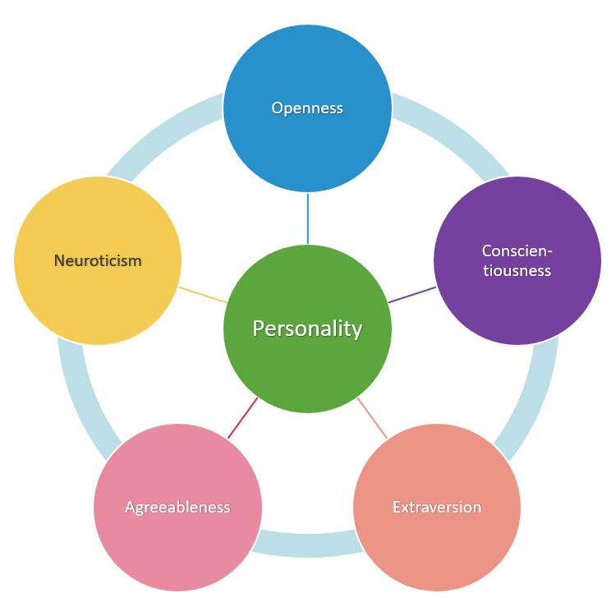

**Figure 1-1.4:** Big five personality model

**1.2.c Big5 trait and environment impact**

According to [10], Big5 personality traits and environment have an engagement. Following a study, they found that there is a positive correlation between environmental concern and the personality traits of agreeableness and openness. They also found the traits of neuroticism and conscientiousness to be correlated, but not as strongly. In this study, they determined if concern and attitudes were also related to performing pro-environmental behaviors. The purpose of this study was to explore if there was a positive relationship between one or more personality traits of the big five and proenvironmental attitudes and behaviors[6].

From [6], we started our GreenBig5 (GB5) project to collect user personality traits, from that to find their effect on the environment and have solutions for each type of Big5 personality trait. This could help the government and the enterprise know about their customers and have a strategy for them to reduce their harmful effect on the environment [6,10].

#### 1.3 Conceptual description

Below are the concept of this project which is the main core of this project:

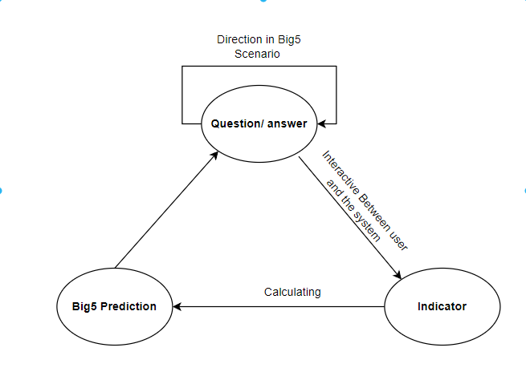

**Question/ Answer(1):** Interact with the user by sending questions and receiving answers directed by the Scenario. Following the Scenario and (3), the system continues to interact with the user to have a specific view of the user’s personality traits.

**Indicator(2) ( Big5 Indicators[*]):** From Question/Answer, the system can extract information according to the app-user’s answers to calculate indicators.

**Big5 Prediction(3):** Based on the calculated indicators, the user's personality traits can be predicted.

This repeatable life cycle can be performed multiple times to train and test the system based on the Q&A package and its workflows. As a result, the user's personality can be classified.

#### 1.4 Project goal

The aim of this project is to build a GreenBig 5 information system (GB5), i.e. GB5 App, database and GB5 Dashboard:

GB5 App: User data can be collected and used to predict her/his personality by sending questions and receiving answers(1).

GB5 Dashboard: Support for creating question packages which used to direct the user follow the environment theme. With each question, users can be distributed by Indicator (2). Finally, by using a prediction method to predict the user's personality traits(3).

As a result, government authorities, enterprises, as well as users would have an overview of the environment and have a better solution to change user behaviour and to reduce and prevent it from the bad effect.

### 2. Problem Definition

#### 2.1 Non-functional requirement

Below are the non-functional requirement that are being offered for this system:

* **Security**: Users can use the system without the fear of revealing personal information.
* **Usability**: with a friendly and flexible user-interface, users can have a great experience when using the system.
* **Portability and compatibility**: The system is operated on the Fullter framework and has the ability to run on any Operating system such as Android or IOS.

#### 2.2 Functional requirement

Below are the functional requirement that are being offered for this system, which are the main purpose of this project:

* GB5 Application
  + Login/Sign in: Users can login to the BG5 Application to use it if they already have an account, or they can register if they don’t.
  + View the question: Users can see the question in the BG5 Application.
  + Answer the question: Users can answer the question in the application.
* GB5 data management system
  + Store user information.
  + Store Big5 indicator, so that the Model can receive to predict Big5 traits.
  + Store user’s Answer.
  + Interact with the GB5 App to show the question.
  + Send the big5 questions based on the big5 scenario [**].
  + Show data into a dashboard to manage the data.
* GB5 Dashboard
  + Visualize User trait data, sent question and the answer
  + Visualize User trait point
  + Send question to user setted by Big5 Scenario [**].
  + Store question, Big5 Indicator [*].
  + Modify the question package.

#### 2.3 Some definition in this project

In this project, you would see some strange words or theoretical definitions, this could explain shortly about them:

**Big5 indicator [*]**

The Big5 indicators are the characteristics, a sign of presence or absence of one or many Big5 traits.

As we know Big5 divides into 5 different traits (O.C.E.A.N) [6,7,8,10]. Based on that the Big5 indicator will be retrieved and calculated from these traits. Some example of the big5 indicator are:

* Logic game: Calculated when the users answer the question about their hobbit with the logical game.
* Do something during an argument or business: Calculated when users answer the question about their behavior when they have a fight or an argument.
* Detail-oriented: Calculated when users answer the question about the behavior about their daily life/work.

By using the Big5 indicator, we can calculate the Big5 trait of the user based on their answer on the GB5 Application. This support will set-up a data-set for machine learning.

**Big5 Scenario [**]**

The Big5 scenario provided a questions/answers route for the GB5 Application based on many types of users such as: the new user, the user who has been using the Application,... Not only that, this set-up rule sends the question to a specific user’s group. This would help the system have a specific for classifile user personality trait.

**Pro-Environmental behaviors:** Behaviors that are aimed at reducing climate

change or consequences of climate change (Gifford, 2008).[6]

**Pro-Environmental concern:** Values, attitudes, and beliefs that a person has that

leads them to be ecologically conscientious (Jimenez-Sanchez, & Lafuente, 2008). There

is also a belief that all people have a relationship with the environment (Jimenez-Sanchez

& Lafuente, 2008). Often these attitudes will lead to behaviors or actions to protect the

environment. The terms concern and attitude may be used interchangeably.[6]

### 3. Current Status of Art

These are some research had been made to find the connection between Big-five personality trait and environmental behavior:

[6] is research created by Tara Rae Wuertz from Walden University, Minneapolis, Minnesota. USA in 2015. By surveying the student, they have found the correlation with a person's pro-environmental behavior and the big5 personality traits. [<https://www.proquest.com/openview/f425c164f6b1921a0de75c9ef707de98/1?pq-origsite=gscholar&cbl=18750>]

[7] is a project operated by Doctor. Habil. Binh, Thanh Nguyen and partner to find the user’s personality trait by using their mobile log data. [<https://link.springer.com/chapter/10.1007/978-981-32-9186-7_25>].

[8] is a website to find user’s big-five traits by using a specific survey call - big5 survey. This also has a lot of research about big-five, and the big-five’s usability [<https://bigfive.vn/>].

It can be seen that Big-five personality traits have been used in many different ways such as finding jobs, directing users to use suitable services…. But now, we are facing the consequences of what we do to the environment. By using Big5 personality traits this would help the government and the enterprise and any organization who has interest in the environment problem.

Although Big5 models have been applied in many software products to help people in making decisions, there wasn't any help in making decisions to protect the environment [6,10]. This is the reason we built this system called Big Green 5 (GB5), which includes a BigGreen Application to collect user data, the BigGreen Dashboard to generate the question and calculation to predict the personality of the user based on the answer and the indicator. With the BigGreen system - the first system to help governments and organizations in protecting the environment in the market, we can find out the user's personality, after that we find the impact of the user to the environment to have a better solution to limit bad effects to the environment.

### 4. Engineering Approach (including solution alternatives)

#### 4.1 System Architecture

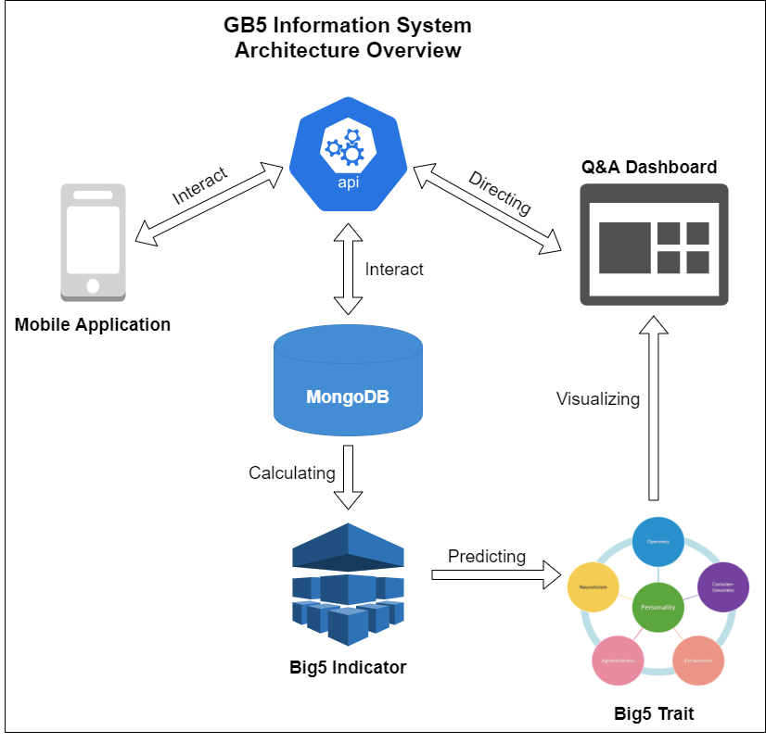

**Figure 1-4.1:** The overview of *GreenBig5 System*

In this system, The GB5 Application is used to collect user data based on the Big-five questions that have been answered, which have been stored in the database.

Besides, the GB5 database will store Big5 indicators, and questions, as well as store user’s data and their personality traits. also store the question pack on each trait for the user, who has been using the application. Based on the big5 scenario[**], the GB5 database can send questions to the GB5 Application for the user to view and answer. This would help the system send the question to the user without intruding on the user's private life.

Finally, the GB5 Dashboard creates the question package and visualizes answer data. So that the system will classify the user into a temper group ( O,C,E,A,N) based on the Big5 Indicator[*]. The Adimin will resend a question to those group following by the rule from Big5 Scenario[**]. The system will re-filter the user to get a specific view of user personality. By collecting the user’s answer data the system will find the user's trait point which will be set-up for the machine learning. For example:

User A answer the question package, the system calculate he/ she have trait point base on the Big5 Indicator[*] set {O,C,E,A,N} = {80,65,55,40,40} can be set as {H,M,M,L,L} at this moment user A will be set in the O team. After that, the Content Manager will send a question with the Big5 indicator showing {O,C,E,A,N} = the O has high point (H) to the O team. Also, if C and A are medium points (M) in the Big5 indicator [*] the system sends this question to the C and A team as well.

#### 4.2 System Detail

**4.2.a GB5 App**

* Interact with users using the system.
* Interact with users using the system.
* Interact with users using the system.
* Interact with user using the system
* Allow user to use these function:
  + Login/Sign up.
  + View the question.
  + Answer the question.
  + Logout
  + Edit user information
* Interact with GB5 Database to store data.
* Collect user information: Phone number.
* Show Big-five questions for the user to answer.

**4.2.b GB5 Database**

* Storage user data, user personality trait, Big-five question and indicator.
* Interact with GB5 Application to send questions based on the Big-five scenario [**].
* Receive a question in the dashboard and send it to the user.

**4.2.c GB5 Dashboard**

* Visualize User trait data, sent question and the answer
* Visualize User trait points.
* Send question to user set based on Big5 Scenario [**].
* Store question, Big5 Indicator [*].

#### 4.3 Technical to develop

Main programming language: JavaScript, Dart.

**4.3.a GB5 Application:**

* Programming Language: Dart, Flutter.
* Tool: Android studio.

**4.3.b GB5 Database:**

* Programming Language: NodeJs
* Database: MongoDB
* Tool: Visual studio code.

**4.3.c GB5 Dashboard:**

* Programming Language: NodeJs
* Tool: Visual studio code.

**4.3.d Communication, Management, Design tool**

* Communication: Skype, Mail, Slack.
* Management: Github, Trello.

### 5. Tasks and Deliverables

#### 5.1 Tasks

|  |  |
| --- | --- |
| Task Number | Task title |
| 1 | Prepapreration. |
| 2 | Collecting Big-five data. |
| 3 | Collecting Big-five indicators[*] and building Big-five questions from the indicator and finding from other sources. |
| 4 | Inspecting Big-five indicators[*] and questions. |
| 5 | Build the question/answer scenario[**] based on Big-five trait |
| 6 | Build UI for GB5 Application. |
| 7 | Physical database design. |
| 8 | Build a demo of the GB5 Application with the scenario. |
| 9 | Build GB5 database. |
| 10 | Import Big-five indicator[*] and Big-five questions into the GB5 database. |
| 11 | Design GB5 Dashboard UI |
| 12 | Develop GB5 Dashboard |
| 13 | Visualize User data into the Dashboard |
| 14 | Send question function testing |
| 15 | Release. |

**Table 5.1:** Tasks

#### 5.2 Deliverables

|  |  |  |
| --- | --- | --- |
| **No** | **Active(s)** | **Deliverables** |
| 1 | Project proposal | Project proposal document v2.2 |
| 2 | Project Plan | Project plan document v2.4 |
| 3 | User Story | Use Story document v.1.3 |
| 4 | Sprint backlog & Burndown Chart | Sprint backlog & Burndown Chart v1.4 |
| 5 | Architecture Document | Architecture Document v1.3 |
| 6 | Database Design | Database Design Document v1.1 |
| 7 | Interface Design | Interface Design Document v1.1 |
| 8 | Test plan | Test plan document v1.0 |
| 9 | Test case | Test case document v1.0 |
| 10 | Acceptance Criteria | Acceptance criteria v1.0 |
| 11 | Team Reflection | Team reflection v1.0 |
| 12 | Technology stack | Technology stack document v1.0 |
| 13 | Description of requirement | Description of requirement v1.0 |

**Table 5.2:** Deliverables

### 6. Project Management

#### 6.1 Human resources

|  |  |  |  |
| --- | --- | --- | --- |
| **Full name** | **Phone** | **Email** | **Position** |
| Binh, Thanh Nguyen | 0905 881 881 | binh.iiasa@gmail.com | Mentor, Stakeholder |
| Chinh, Huu Thai | 0962 545 506 | huuchinhdev@gmail.com | Content management |
| Chung, Bao Hoang | 0889 192 932 | baochunga1@gmail.com | Back-end Developer |
| Loc, Tien Nguyen | 0932478789 | nguyentienloc18122000@gmail.com | Back-end Database |
| Hau, Bui Phuc | 0906 518 281 | bphau121020@gmail.com | Application developer |

**Table 6.1:** *Human Resources*

#### 

#### 6.2 Cost/Budget for Project

|  |  |  |
| --- | --- | --- |
| **Sprint** | **Duration(hour)** | **Cost($)** |
| 1 | 376 | $752 |
| 2 | 356 | $712 |
| 3 | 387 | $774 |
| 4 | 498 | $1996 |
| **Total** | **1617** | **$4234** |

**Table 6.2:** *Cost/Budget for Project*

#### 6.3 Tentative Schedule

|  |  |  |  |  |
| --- | --- | --- | --- | --- |
| **No** | **Task name** | **Duration** | **Start** | **Finish** |
| **1** | **Pre-study** | **16 days** | **15-Aug-2021** | **04-Sep-2021** |
| 1.1 | Gathering requirement | 2 days | 15-Aug-2021 | 17-Aug-2021 |
| 1.2 | Create proposal document | 6 days | 17-Aug-2021 | 22-Aug-2021 |
| 1.3 | Project Kick-off Meeting | 1 days | 23-Aug-2021 | 23-Aug-2021 |
| 1.4 | Submit proposal | 3 days | 24-Aug-2021 | 27-Aug-2021 |
| 1.5 | Present proposal | 5 days | 29-Aug-2021 | 04-Sep-2021 |
| **2** | **Development** | **84 days** | **06-Sep-2021** | **12-Dec-2021** |
| 2.1 | Sprint 1 | 28 days | 06-Sep-2021 | 03-Oct-2021 |
| 2.2 | Sprint 2 | 28 days | 04-Oct-2021 | 31-Oct-2021 |
| 2.3 | Sprint 3 | 28 days | 01-Nov-2021 | 28-Nov-2021 |
| **3** | **Retrospective** | **1 days** | **15-Dec-2021** | **15-Dec-2021** |
| **4** | **Final Release** | **3 days** | **16-Dec-2021** | **18-Dec-2021** |

**Table 6.3:** *Master plan*

#### 6.4 About Scrum

Scrum is an agile method, so it follows the principles of Agile Manifesto (<http://hanoiscrum.net/hnscrum/learning/97-manifesto>). In addition, Scrum operates on three core values, also known as Scrip Scripps, including Scrutiny, Inspection and Adaptation.

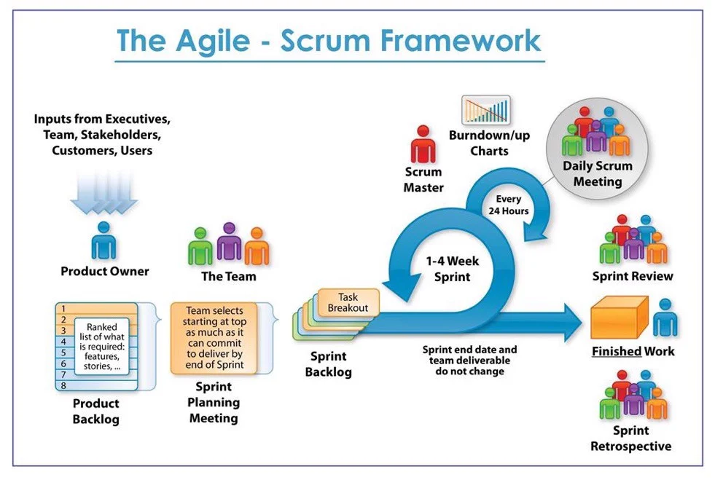

**Figure1-6.3** *The Agile-scrum framework*

Based on the empirical process control theory, Scrum uses iterative and incremental algorithms to optimize efficiency and control risk. Scrum is simple, easy to learn, and has wide applicability. To be able to use Scrum, we need to understand and apply the elements that makeup Scrum include the core values (also known as the "three legs", or the three pillars of Scrum), roles, Events, and Scrum-specific artifacts.

#### 6.5 The reason we use Scrum

* Team have 4 members
* The project will be continuously horizontally scaled up.
* There is only a short amount of time to finish the project.

So for these reasons, we believe using Scrum as a life cycle is a good choice for this project.

### 7. Project Constraints

|  |  |  |
| --- | --- | --- |
| **Constraint** | **Constraints Description** | **Guidelines for Acceptance** |
| **Economic** | In terms of cost, because it is a system for collecting data for classification purposes, the main problem lies in the cost of research, implementation of a fully automatic system and intelligent user interface. There is also the cost of server rental and server deployment, advertising, ... | Human resource cost: Must be around $600.  Maintenance cost: Should be around $500.  Operation cost: Should be under $1200  Installation costs each intersection around $1000. |
| **Environmental** | This supports organizations to reduce and have solutions to protect the environment. As well raise awareness to users about their behavior impacting the environment. | Support for reducing bad affect of human to environment |
| **Public health, safety, and welfare** | By raising awareness about the user's personality to the environment, this could increase user health. | Reduce all health problem course by environment problem |
| **Social and Global** | **Benefit:**  Help organizations and governments to help people in protecting the environment.  **Risks:**  It can be affected in the user lifestyle while the government or the organization apply solutions based on what we provide. | Addresses aspects such as benefits, risks, the man-machine interface, the acceptance of products by the intended user or by society at large, global and socially responsible engineering. |
| **Sustainability** | It is necessary to maintain the continuous operation of the system, so that system can update user data frequently | Development and maintenance work must be ensured to take place continuously, when issues are reported, it is necessary to focus on maintenance immediately. Server the operation also needs to be ensured not to be interrupted. |

**Table 7**: *Constraints*

### 8. Conclusion

This project will be finished in 17 weeks and divided into 4 sprints. It promises to be convenient and friendly not only for the government, organization … and also those environmental lovers who want to protect it. This will be a handful system for enterprises to help their customers come closer to their product without facing their impact on the environment as well as a handful tool for dealing with many types of customers. For the Government and the Environment Organization, our system will be a good way to find a better solution to reduce and protect the environment and global warming.

### 9. References

[1] The Scrum guide: [The Scrum Guide is maintained](https://www.scrum.org/resources/scrum-guide)

[2] Software Development Standards for the Guidance and Control Software

[3] [LaRC Software Engineering (SWE) Process Improvement Initiative (SPII)](https://sw-eng.larc.nasa.gov/)

[4] General Software Coding Standards and Guidelines [Office of Water Prediction](https://www.nws.noaa.gov/oh/hrl/developers_docs/General_Software_Standards.pdf)

[5] Scrum and best practices [Sprint and scrum best practices - Azure Boards](https://docs.microsoft.com/en-us/azure/devops/boards/sprints/best-practices-scrum?view=azure-devops)

[6] Personality Traits Associated with Environmental Concern: <https://www.proquest.com/openview/f425c164f6b1921a0de75c9ef707de98/1?pq-origsite=gscholar&cbl=18750>

[7] Tracking Big5 traits based on mobile user log data : [Tracking Big5 Traits Based on Mobile User Log Data](https://link.springer.com/chapter/10.1007/978-981-32-9186-7_25)

[8] Big-five Viet Nam: <https://bigfive.vn/>

` [9] Ozone depletion: [Ozone depletion - Wikipedia](https://en.wikipedia.org/wiki/Ozone_depletion#:~:text=The%20discovery%20of%20the%20Antarctic,larger%20than%20anyone%20had%20anticipated.)

[10] [How personality traits are associated with environmental engagement](https://environment-review.yale.edu/how-personality-traits-are-associated-environmental-engagement-0): <https://environment-review.yale.edu/how-personality-traits-are-associated-environmental-engagement-0>

[11] Vietnam Veterans' Readjustment: Hearings Before the Committee on Veterans:

[Vietnam Veterans' Readjustment: Hearings Before the Committee on Veterans ... - United States. Congress. Senate. Committee on Veterans' Affairs - Google Sách](https://books.google.com.vn/books?id=wmYSl3I6uj8C&pg=PA40&lpg=PA40&dq=Nowadays,+the+environmental+problem+is+the+most+concerning+problem+not+only+in+Viet+Nam+but+the+World+as+well&source=bl&ots=ooSJ4HCC3h&sig=ACfU3U0GDZN2rSeX9YQHiOud7wGne5_Iag&hl=vi&sa=X&ved=2ahUKEwjR5NGG89jyAhUzyIsBHZWDBuUQ6AF6BAgoEAM#v=onepage&q=Nowadays%2C%20the%20environmental%20problem%20is%20the%20most%20concerning%20problem%20not%20only%20in%20Viet%20Nam%20but%20the%20World%20as%20well&f=false)

[12] Big5 Application: [big-five app list - Tìm trên Google](https://www.google.com/search?q=big-five+app+list&sxsrf=AOaemvKA_eOj77p7-ag-C6YUHH1evhu83A%3A1630324679693&ei=x8csYbvwKZaKr7wPjaqqmA8&oq=big-five+app+list&gs_lcp=Cgdnd3Mtd2l6EAMyBwgAEEcQsAMyBwgAEEcQsAMyBwgAEEcQsAMyBwgAEEcQsAMyBwgAEEcQsAMyBwgAEEcQsAMyBwgAEEcQsAMyBwgAEEcQsANKBAhBGABQ_RJY_RJgxBZoAXACeACAAQCIAQCSAQCYAQCgAQHIAQjAAQE&sclient=gws-wiz&ved=0ahUKEwj775rb2NjyAhUWxYsBHQ2VCvMQ4dUDCA8&uact=5)

[13] Psychology’s Essential Role in Alleviating the Impacts of Climate Change: [2008 Psychology's essential role in climate change.pdf (uvic.ca)](http://web.uvic.ca/~esplab/sites/default/files/2008%20Psychology's%20essential%20role%20in%20climate%20change.pdf)

[14] The Impact of Climate Change on the Agricultural Sector: Implications of the Agro‐Industry for Low Carbon, Green Growth Strategy and Roadmap for the East Asian Region: [Microsoft Word - Final_Paper_The Impact of Climate Change on the Agricultural Sector.doc (unescap.org)](https://www.unescap.org/sites/default/d8files/5.%20The-Impact-of-Climate-Change-on-the-Agricultural-Sector.pdf)

[15] Local Warming: Daily Temperature Change Influences Belief in Global Warming: [Local Warming: Daily Temperature Change Influences Belief in Global Warming - Ye Li, Eric J. Johnson, Lisa Zaval, 2011 (sagepub.com)](https://journals.sagepub.com/doi/abs/10.1177/0956797611400913)

10. Attachment: DESCRIPTION OF PRODUCT REQUIREMENTS FORM